AI SOC Assistant
Automated Security Operations Center Log Analysis Tool
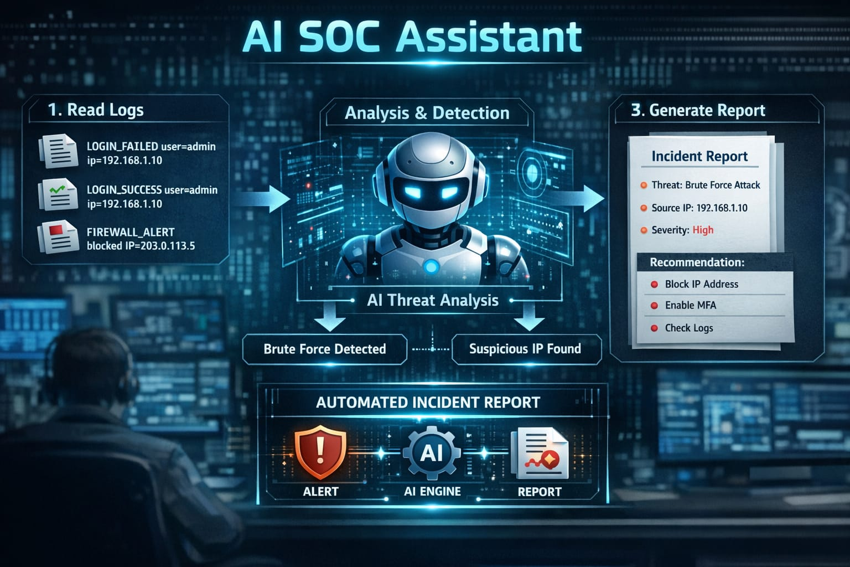

1. Project Documentation
Project Name: AI SOC Assistant
Project Type: Cybersecurity / Security Operations Center (SOC) Automation
Technology Used: Python, Log Analysis, OpenAI API (Optional)

2. Project Overview
Description:
AI SOC Assistant is an automated cybersecurity tool designed to simulate the workflow of a Security Operations Center (SOC). The system analyzes Linux authentication logs to detect potential cyber attacks such as brute force attempts, port scans, and suspicious login behavior.
The project parses system log files, applies detection rules to identify suspicious activities, and generates SOC-style incident reports. Additionally, the tool can optionally use artificial intelligence to provide human-readable explanations of detected threats, helping security analysts understand attack patterns more efficiently.
Key Objectives:
Objectives of the Project
The main objectives of this project are:
- To automate the analysis of Linux authentication logs
- To detect common cyber attacks such as brute force and port scanning
- To generate structured SOC incident reports
- To simulate real-world SOC monitoring processes
- To demonstrate the integration of AI for cybersecurity threat analysis
- Detect cyber attacks:
  - Brute Force
  - Port Scan
  - Multi-user login attempts
  - Normal activity tracking
- Generate structured SOC incident reports
- Provide AI-based threat analysis
- Support large log datasets (500–2000+ entries)
- Modular, extendable Python-based architecture
Key Features
- Log parsing from Linux authentication logs (auth.log)
- Brute force attack detection
- Port scan detection
- Multiple user login attempt detection
- Automated SOC incident report generation
- Optional AI-based threat analysis
- Synthetic log generation for testing large datasets

Target Users
This project is intended for:
- Cybersecurity students
- SOC analysts
- Security researchers
- Anyone learning about log analysis and threat detection
Development Environment
- Operating System: Kali Linux
- Programming Language: Python
- Tools Used: Git, GitHub, OpenAI API (optional)

3. Project Architecture
Workflow Diagram:
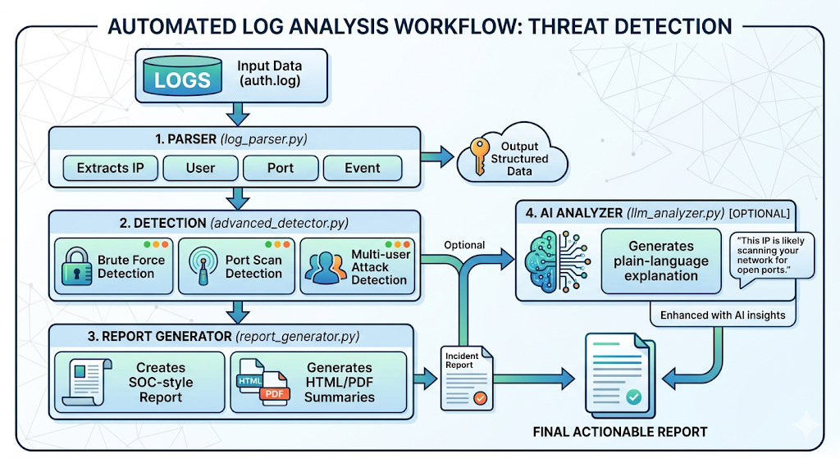
Description:
- Logs → raw authentication logs from Linux or generated logs
- Parser → extracts structured data
- Detection → applies thresholds and rules to identify attacks
- Report Generator → formats results into SOC-style reports
- AI Analyzer → optional GPT-4 explanation for analysts

4. Folder Structure
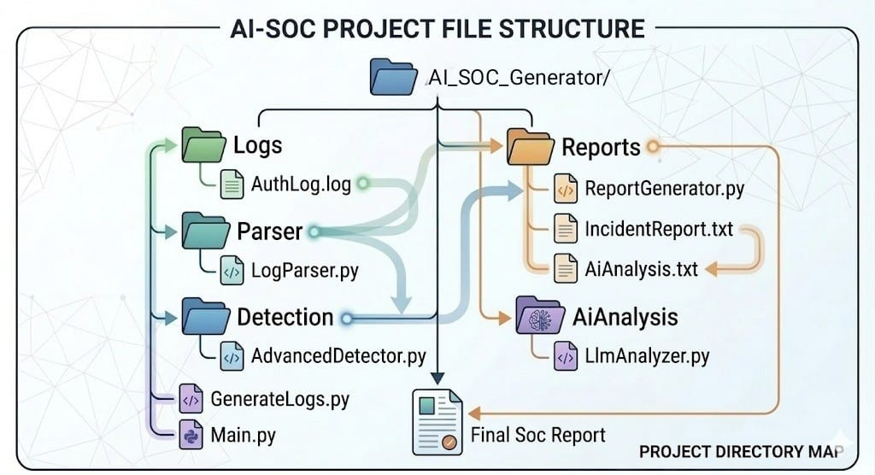

5. Environment Setup
Requirements:
- Python 3.10+
- Pip packages:
pip install openai
- Optional: Linux auth.log file
- Optional: OpenAI API key for AI analysis
Set API Key:
export OPENAI_API_KEY="sk-XXXXXXXXXXXXXXXXXXXX"
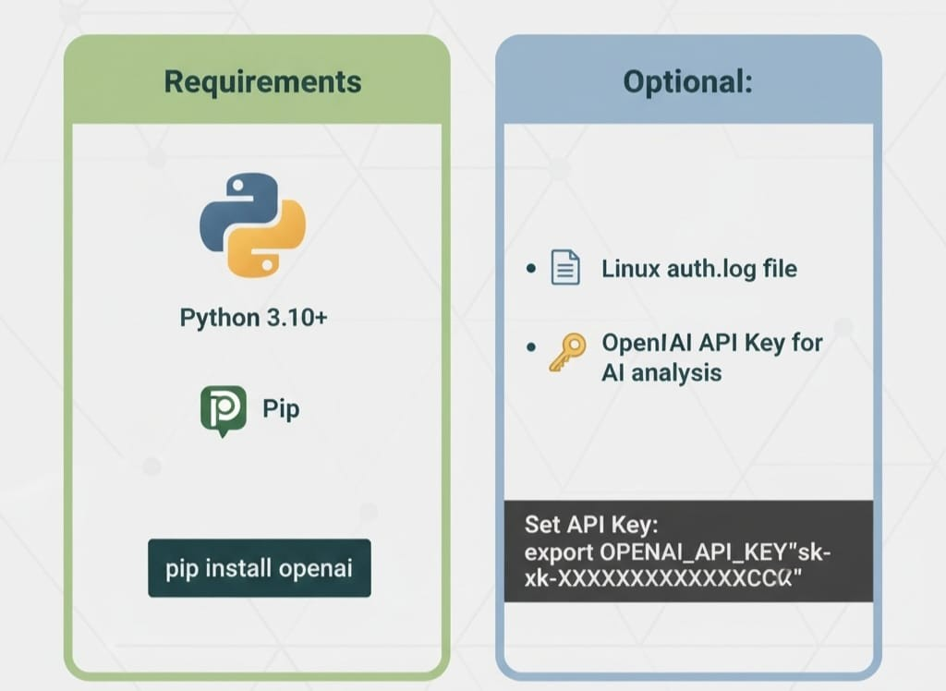

6. Module Description
A) Generate_Logs.py
- Generates synthetic authentication logs with all attack types
- Configurable num_logs (500–2000+)
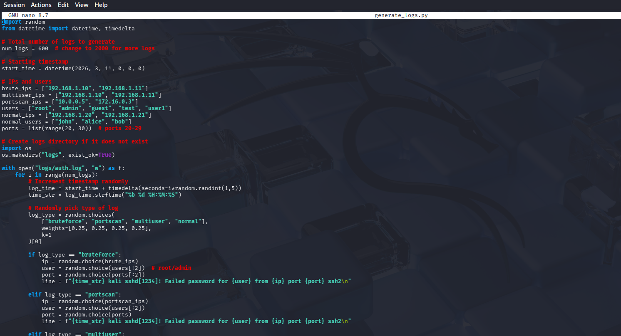

B) Parser/Log_Parser.py
- Reads logs and extracts: timestamp, IP, username, port, status
- Produces structured events for detection
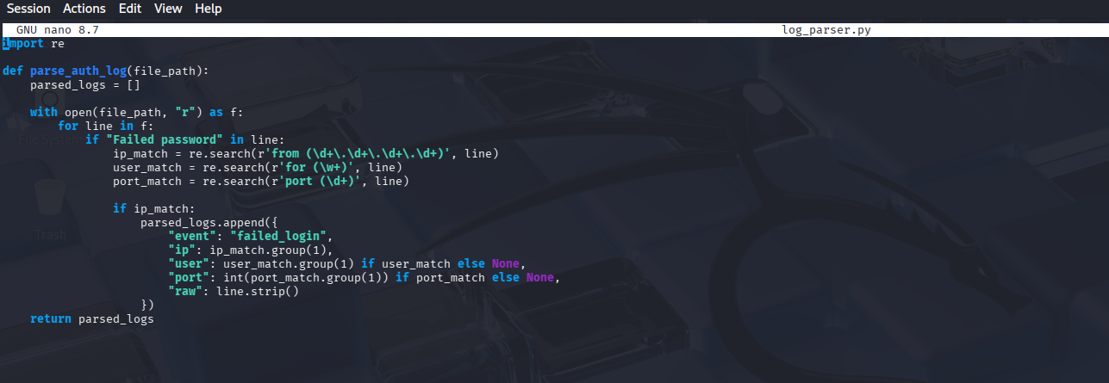

C) Detection/Advanced_Detector.py
- Detection rules:
  - Brute Force → threshold > 5 failed attempts
  - Port Scan → threshold > 10 ports
  - Multi-user attempts → threshold > 3 usernames
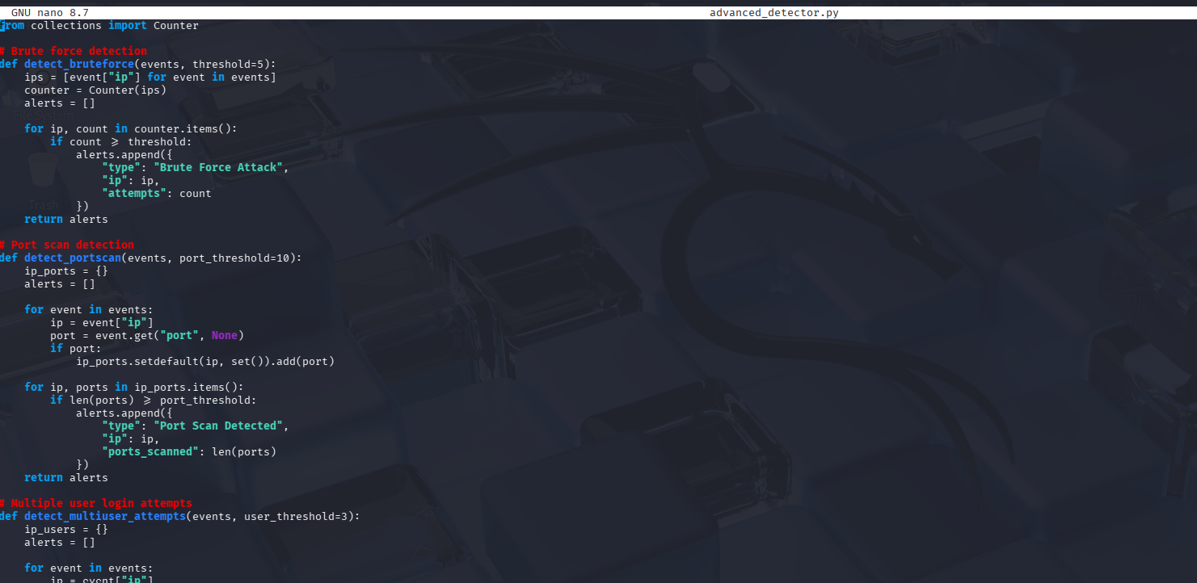

D) Reports/Report_Generator.py
- Converts alerts into SOC incident report
- Sample Example:
SOC Incident Report
Generated: 2026-03-11
----------------------------------------
Threat Type : Brute Force Attack
Source IP : 192.168.1.10
Attempts : 7
Threat Type : Multi-user Login Attempts
Source IP : 192.168.1.11
Users Tried : ['root', 'admin', 'guest']
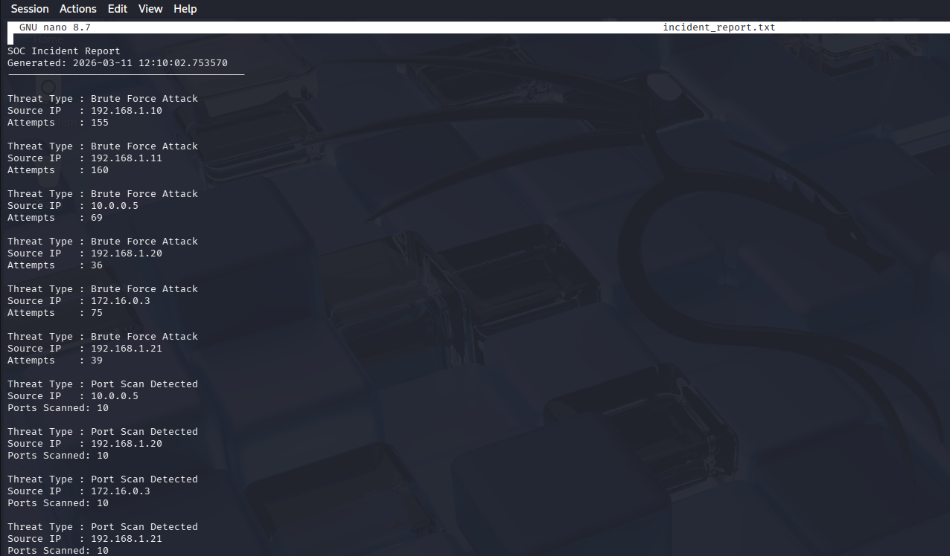

E) AI_Analysis/LLM_Analyzer.py
- Optional AI module (GPT-4)
- Converts alerts to human-readable explanation:
AI Threat Analysis:
- IP 192.168.1.10 attempted 7 failed logins → possible brute force
- IP 192.168.1.11 tried multiple usernames → credential guessing attempt
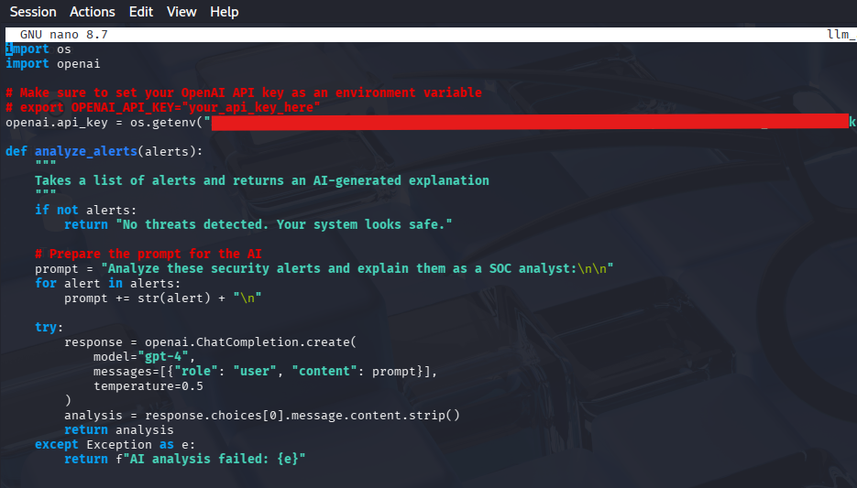

F) Main.py
- Orchestrates the workflow:
1. Parse logs
2. Detect attacks
3. Generate SOC report
4. Run AI analysis (optional)
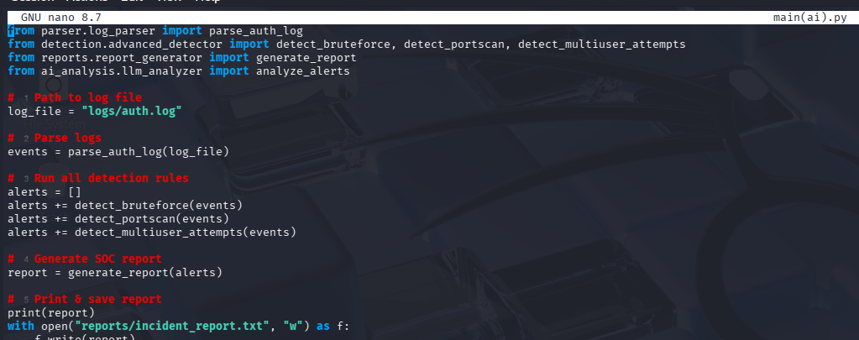

7. Usage Instructions
- Generate logs:
python3 generate_logs.py
- Run SOC Assistant:
python3 main.py
- Outputs:
- reports/incident_report.txt → SOC report
- reports/ai_analysis.txt → AI analysis (optional)

8. Key Features
- Detects Brute Force, Port Scan, Multi-user login attempts
- Generates SOC-style incident reports
- Provides AI analysis for plain-language insights
- Supports large datasets (2000+ logs)
- Modular & extendable architecture

9. Optional Extensions
- Real-time log monitoring (tail -f auth.log)
- Email notifications for critical alerts
- Additional detection rules (sudo failures, unusual login times, geolocation analysis)
- Integration with SIEM platforms

10. Conclusion
AI SOC Assistant is a complete end-to-end SOC simulation that:
- Parses and analyzes logs
- Detects multiple attack types
- Generates clear SOC reports
- Optionally explains attacks using AI (GPT-4)
- Can be used for security labs, portfolio projects, or SOC training

